
KENYA SCHOOL OF LAW
___________________________________________________
ADVOCATES TRAINING PROGRAMME
ACADEMIC YEAR 2022/2023
_______________________________________
ATP 107-CONVEYANCING
___________________________
COMPLETION DOCUMENTS FOR SALE AGREEMENTS
FOR A PLOT OF AGRICULTURAL LAND AND A PORTION OF LAND SOLD SUBJECT TO DIVISION

________________________
COURSE COORDINATOR: MS. LEAH KIGUATHA

FIRM 6, CLASS ‘E’-2022

 | ADM NO. | NAME
1. | 20221890 | MUUSYA DUNCAN
2. | 20220364 | KANGANGI MARGARET
3. | 20220456 | NYAMBARIRO EUGENE
4. | 20220718 | ODUOR GEORGE
5. | 20220828 | KARANJA HERBERT
6. | 20221438 | NJIHIA RICHARD
7. | 20220960 | OUNO SHARON
8. | 20221280 | NEKO BRYAN

DATE: 26TH DAY OF MAY 2022

Introduction
Once a valid sale agreement has been prepared and executed, the stage or step that follows is the completion. As discussed earlier a sale agreement is merely executory and gives no interest. Completion under condition 2 of the Law Society of Kenya Conditions of Sale and Agreement for Sale Layout defines completion as the act of completing the sale of the property for consideration pursuant to the agreement by the parties. Therefore, the stage involves an exchange of requisite documents for the balance of the purchase price. Completion documents refer to the final submissions that are made by the vendor or their advocate to the purchaser of land or their advocate to complete the transfer of land which is the subject of their contract.
While the purchaser completes the transaction by giving the balance of consideration, the vendor on the other hand completes it by handing over possession. Completion involves:
- The process usually involves the transfer (by registration) of the interest in property to the purchaser.
- Granting of legal possession of the property to the purchaser.
- Settling of utility bills and transfer of utility accounts.
- Apportionment of outgoings between the vendor and the purchaser.
The vendor is required to give the purchaser all the registrable documents. The completion documents are also known as deliverables. This is provided for under condition 7 of the Law of Society of Kenya Conditions of Sale and Agreement for Sale Layout. Condition 7.1 provides for the application of completion documents. The vendor’s advocate applies for the relevant documents from the relevant authorities and communicates the information to the Purchaser’s advocate and provides a copy of the same, to show the ability to complete.
There are standard completion documents that are found in every transaction such as a copy of the vendor’s ID, passport photos of the vendor as well as the vendor’s KRA pin certificate. However, certain documents are peculiar to particular transactions. Completion documents vary depending on the tenure. Section 49 of the Land Registration (General) Regulations,2017 generally highlights the requisite documents for a transfer. An application for the transfer of an interest in land shall be supported by the following documents: -
- the original title documents
- where applicable, a land rent clearance certificate
- a land rates clearance certificate
- where applicable, the consent of the head lessor
- any consent required for registration unless a particular consent has been endorsed on the instrument of transfer.
- where applicable, a form for Valuation of Stamp Duty duly filled and approved by a government valuer.
- any other document as may be required under the Act, these Regulations or any other written law (the list is thus not exhaustive)
The paper will highlight the requisite completion documents for a sale agreement for a plot of agricultural land and a sale agreement for a portion of land sold subject to subdivision. The paper will also attempt to expound on the rationale behind the requirement of certain documents.

1.0 Sale Agreement for a plot of agricultural land
Clause 3 of the sale agreement provides for the completion stage and states the following as deliverables:
- The original title deed of the Agricultural land.
- The duly executed transfers (in triplicate) in respect of the property (agricultural land).
- Three passport-sized photos of the vendor.
- Copies of the vendor’s identity card and Kenya Revenue Authority Pin Certificate.
- Consent from the land control board to transfer the Agricultural plot of land (Nota Bene).
- A valid rent clearance certificate. (Note that a rate clearance certificate is not applicable when it comes to the transfer of agricultural land).
- Duly completed and signed stamp duty valuation forms in the form prescribed.
- All other documents that may be deemed necessary for the successful registration of the Transfers in favour of the Purchasers.

(i) The original title deed of the Agricultural land
A title deed is prima facie proof of ownership and since it is a transfer of ownership from the vendor to the purchaser the document needs to be transferred to be presented for registration.
(ii) Three passport-sized photos of the vendor and an ID card
It serves as proof of identity.

(iii) Copies of vendor’s KRA Pin certificate
A KRA pin is a unique identification number given by the Kenya Revenue Authority. It uniquely identifies you for purposes of conducting business with the Kenya Revenue Authority and other government agencies such as the Ministry of Lands (There are certain taxes that will accrue e.g., CGT,Stamp duty)

(iv) Letters of consent from the Land Control Board (A completion document that is peculiar to agricultural land)
Consent is required for all Agricultural Land as defined in section 2 of the Land Control Act.
Thus, all the transactions concerning agricultural land have to be approved by the Land Control Board that sits within the area in which the agricultural land is located within 6 months of making the sale agreement between the parties.
Transactions in which an LCB consent is required: -
- Sale, transfer, lease, mortgage, exchange, partition, and other disposal or dealing with any agricultural land.
- Division of any such agricultural land into two or more parcels to be held under separate titles other than the division of an area less than 20 acres into plots in an area to which the Development and Use of Land (Planning) Regulations.
- The issue, sale, transfer, mortgage, or any other disposal of or dealing with any share in a private company or cooperative society that for the time being owns agricultural land situated within a land control area.
- A declaration of trust of agricultural land situated within a control area dealing in that land.
Exemptions from consent include: -
- Exempted granted by the President under the gazette notice
- Transmission under a will or intestacy of a deceased person unless the same would result in the division of the land into two or more parcels held under two separate titles.
- Transaction to which the government or the Settlement Fund Trustees (In respect of trust land) of a county council is a party.
In the case of Hirani Ngaithe Githire v Wanjiku Mange a brother had sold a parcel of land to his sister in 1969. They had not sought the consent of the Land Control Board . She had paid full price, taken possession and made some developments to it. The Appellant refused to effect a legal transfer of land. The Respondent had filed a suit for specific performance. The court affirmed that the consent is imperative and equity cannot soften it considering they had not sought consent. The same was opined in Silas Bartonjo Kiptala v James Kipkemboi Murei.

(v) A valid rent clearance certificate
There are two main types of clearance certificates sought in conveyancing transactions; these are land rent clearance certificates and land rate clearance certificates. A land rent clearance certificate applies specifically to properties held under a lease from the government under which the proprietor is required to pay a certain amount of rent. This is provided under section 39(1) of the Land Registration Act. The registrar cannot register any instrument (transfer, charge, lease) if land rents are owing to the national or county government. It is payable by a person who is registered as proprietor lessee from the government of Kenya. The role of collecting land rents on behalf of the national government shall be undertaken by the National Land Commission as espoused in section 3(a)of the Land Registration Act.

(vi) Duly completed and signed stamp duty valuation forms in the form prescribed
Before duty is determined, the vendor’s advocates must apply for the valuation of the property at the Land Office, which is undertaken by the government valuers, who are required to determine the market value of the property. This application is done by lodging the duly signed transfer of property and the valuation for stamp duty form duly signed by the vendor or his advocates. They are used to determine the stamp duty applicably. Stamp duty is charged on the transfer. 2% is charged on land in the rural areas while land in urban areas is charged 4%. Completing the transfer of property involves the simultaneous payment of both the stamp duty and capital gains tax.
(vii) Consent of the chargee (where applicable)
Where the land to be transferred is charged, it is stipulated in section 59 of the Land Registration Act that the consent of the lender will be required where the charge contains a condition , express or implied by the borrower that the borrower will not, without the consent of the lender, transfer, assign or lease the land or in the case of a lease, sublease, no transfer, assignment, lease or sublease shall be registered until the written consent of the lender has been produced to the Registrar.
In Agnew v Commissioner of Inland Revenue, it was stated that where a fixed charge is being created, the chargee must and should give consent to that transaction. The consent must be express without any hint of duress. A similar position was also held in Re Spectrum Plus Ltd stated that due to the fact that the assets charged as security are usually appropriated to the total amount charged, it gives the chargee a proprietary interest in the asset. The only way assets in an unredeemed charge can be transferred or appropriated is only with the consent of the chargee. The same applies mutatis mutandis with regards to mortgages.

1.2 Sale agreement for a portion of the land-sold subject to division
Clause 5 of the sale agreement provides for the completion stage and states the following as deliverables:
- The original title for the property
- Duly executed transfer (in triplicate) in favour of the purchasers
- Copies of the National Identity Card/Passport of the vendor
- PIN Certificate of the Vendor
- Three coloured passport size photographs of the Vendor
- Spousal consent to the transfer of property (if the land is matrimonial property)
- Rates Clearance Certificate (if applicable)
- Capital Gains Tax payslip
- Land Control Board Clearance Certificate

(vii) Original valuation Report
Before duty is determined, the vendor’s advocates must apply for the valuation of the property at the Land Office, which is undertaken by the government valuers, who are required to determine the market value of the property.

(ix) Spousal consent to the transfer of property
The land laws enacted in 2012 brought with them various reforms in the land sector and also in the manner in which transactions are carried out. One of those reforms includes the requirement of a spousal consent when undertaking a transaction involving matrimonial property as provided for in section 79(3) of the Land Act. Section 28 of the Land Registration Act envisages spousal rights as one of the overriding interests in land or property where such property is considered as matrimonial property. In the sale, charging or leasing of matrimonial property, without valid spousal consent, the registration is deemed to be invalid. Consent can be in the form of a statement or an affidavit by the consenting spouse.

(ix) Land Rates Clearance certificate
As provided under section 38(1) of the Land Registration Act. There is a need to obtain the relevant local and or county government where the property is in a municipality or urban centre. It certifies that the requisite rates have been paid to the relevant authority and that there are no debts and or amounts owing to the same. The Rating Act and the Valuation of Rating Act provide the basis on which rates get charged by the local or county authority. The Rating Act provides that it provides for imposition of rates on land and buildings in Kenya. Rates are payable for both freehold and leasehold properties.
Other required documents (applies to specific circumstances):
- Consent of the head lessor (where the land is leased)
Applies to sub leases or for individuals that have obtained leasehold from the government (as the head lessor) and have the intention to sublease it. The purpose of the consent is to ensure that agreements in the lease are honoured as well as rent being paid.
- Power of attorney
A Power of Attorney is a formal instrument by which a person empowers another to represent him or act in his behalf for certain purposes. The power may be limited and may refer to particular/specific acts or it may be unlimited and general in its form. Therefor if the vendor is acting on behalf of another with regard to the disposition of the land it would be essential for the vendor to include the power of attorney as part of the deliverables.
- Notice of withdrawal of caveat or caution if there are any third parties having an interest in the property
Caveats and cautions are methods of protecting proprietary interest. A caveat is a warning or proviso. Lodging of a caveat over a property is a way of telling anyone who wants to deal with the property to be aware of the fact that someone else’s interest already has priority. Therefore, the purchaser when dealing with the property is made aware of the fact that someone else already has interest in property. Dealings in the land cannot be made without the cautioner’s consent or until the caution has been withdrawn. A caveat can be withdrawn by the cautioner, order of the court or by the order of the registrar (Section 73(2) of the Land Registration Act)

(d) Capital Gains Tax payslip
This is a tax chargeable on the gains that are made by a person on the transfer of immovable property. It is due on or before the application for transfer of the property at the relevant lands office but not later than the 20th day of the month following the transfer at the rate of 5%. Gains are the difference between sale proceeds and the adjusted cost which constitute the historical cost and any incidental cost incurred in the property’s enhancement, preservation and defence of the title.

- Certificate of incorporation in case the vendor is a corporation.
- Consent of any statutory authority having an interest in neighbouring property e.g., Kenya Airports Authority, Kenya Ports Authority.

Conclusion
Deliverables or completion documents are highly sensitive documents (they can be described as the sine qua non of a conveyance) considering that once they are lodged at the land’s office for purpose of registering the transfer of land, an interest in land or ownership is conferred on the purchaser. As a vendor, it is thus imperative to ensure that the balance of the purchase price is paid before handing over the completion documents. The sensitivity of completion documents was highlighted in the case of Nicholas Thuo Kabaiku v Serah Njeri Mbatia (ELC Case No.222 of 2018)

SOME SAMPLES OF THE ABOVE COMPLETION DOCUMENTS

(I) Original title deed of the Agricultural
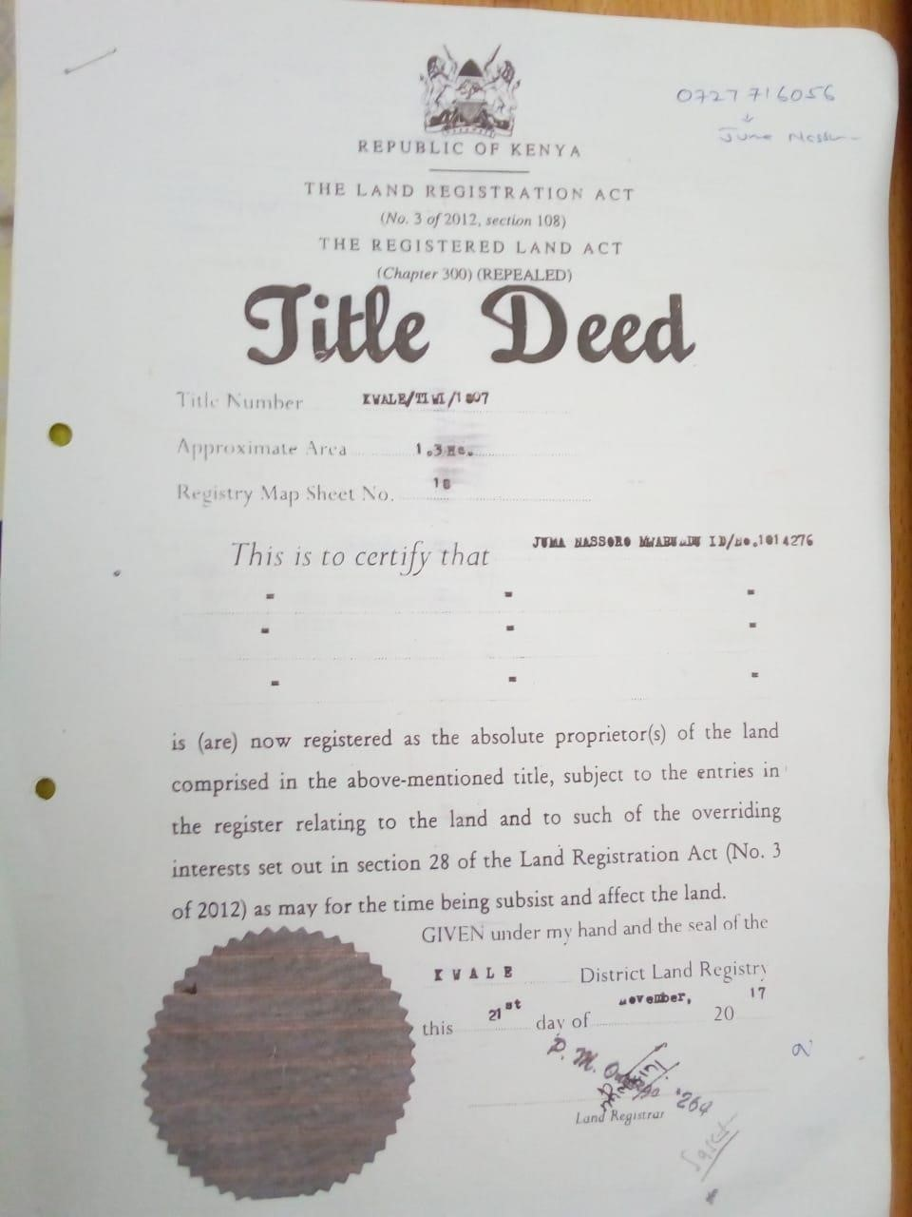

- Copies of the vendor’s identity card and Kenya Revenue Authority Pin Certificate.



- Consent from the land control board to transfer the Agricultural plot of land.

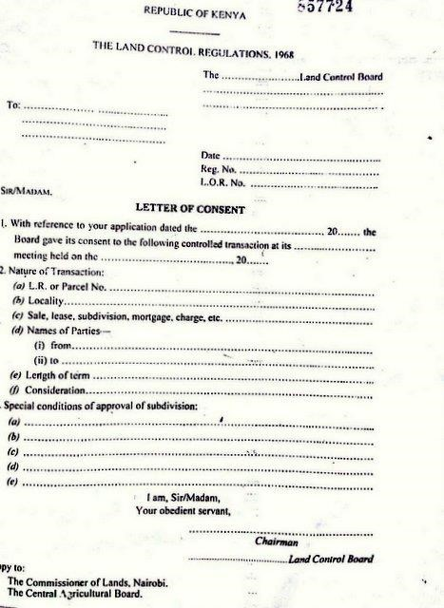

(iv)A valid rent clearance certificate.
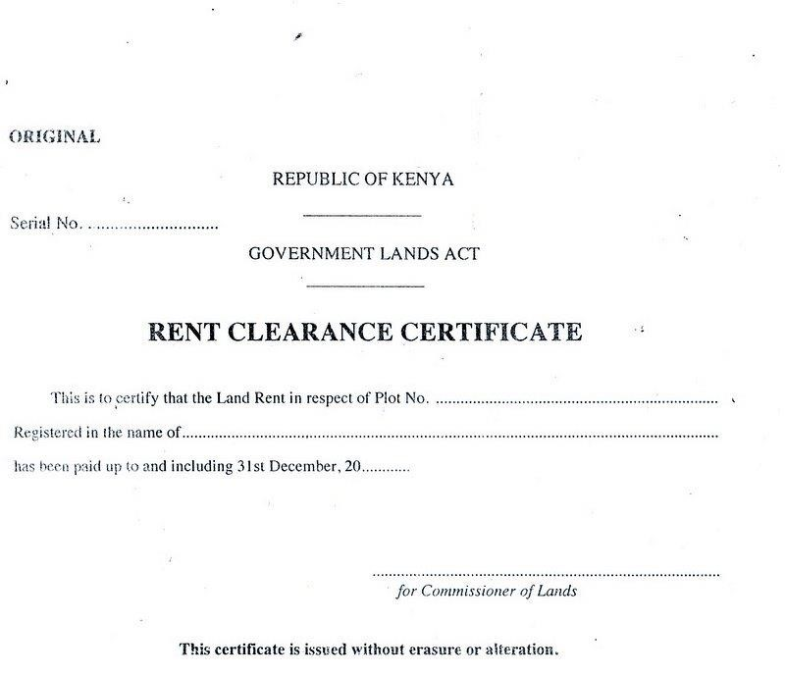

This Phot
o

b
y Unknown Author is licensed unde
r

CC B
Y
-
S
A

(v) Land rate clearance certificate


This Phot
o

b
y Unknown Author is licensed unde
r

CC B
Y
-
S
A

DATED 06/06/2022

AMARU TUPAC SHAKUR

- to –

BIGGIE SMALLS

_________________________________________

POWER OF ATTORNEY
in respect of Land Reference Number 334/6109/8 Kiambu

_________________________________________

Simple, Simpler and Simplest
Advocates
Harambee Building
Oloibon Avenue
P.O. Box 30333-00100
NAIROBI

REPUBLIC OF KENYA
THE LAND ACT NO. 6 OF 2012
THE LAND REGISTRATION ACT NO. 3 OF 2012 AND
THE REGISTRATION OF TITLES ACT (CHAPTER 281) (Repealed)
TITLE NUMBER: I.R 26469

POWER OF ATTORNEY

KNOW ALL MEN BY THESE PRESENTS THAT I AMARU TUPAC SHAKUR of Passport Number K6768377 and of P.O. Box Number 67894-00500 Nairobi Kenya (hereinafter called "the Donor") HEREBY NOMINATE AND APPOINT BIGGIE SMALLS of Post Office Box Number 165435-00500 Nairobi, Kenya (hereinafter called “the Attorney”) to be my lawful attorney in my name and on my behalf to do all or any of the acts and things hereinafter mentioned in relation to my right and power as one of the registered owners of Land Reference Number 786/0876/10 (hereinafter called ‘the Property’) that is to say:

1. To commence carry on or defend or compromise all or any actions or proceedings touching the Property.

2. To execute all such documents (including but not limited to sale agreements, leases, charges and transfers of the Property) as the Attorney may consider necessary or proper for any of the foregoing purposes.

3. Generally, to act in relation to the Property as fully and effectually in all respects as the Donor could do.
4. To sell lease or otherwise dispose of the Property or any part or parts thereof for any such purposes and on any such terms as the Attorney in his sole discretion thinks fit and to obtain any and all consents clearances and/or other documents necessary to effect such dealings in the Property.

5. To register or file or cause to be registered or filed in any official registry or any Court corporation company or person this Power of Attorney and all deeds notices memorials contracts instruments or documents which it may be necessary or expedient to register or file.

AND the Donor HEREBY DECLARES that all acts’ deeds matters and things which shall be given made executed or done for the foregoing purposes by the Attorney shall be as good valid and effectual to all intents and purposes whatsoever as if the same had been given made executed or done by the Donor in his own proper person.

AND the Donor HEREBY UNDERTAKES to ratify everything which the Attorney or any substitute attorneys or attorney or agent or agents appointed by the Attorney under the power in that behalf hereinbefore contained shall do or purport to do by virtue of this Power of Attorney.

IN WITNESS whereof the Donor has hereunto set his hand on this Deed this 9th day of June 2022 .
SIGNED SEALED AND DELIVERED by )
the AMARU TUPAC SHAKUR in )
the presence of: - )
)
)
)
)
Advocate )

I ...........SUGE.........KNIGHT.................................. hereby certify that Amaru Tupac Shakur freely and voluntarily executed this Power of Attorney in my presence.

Name of witness: ...................................................................................
Signature: ...............................................................................................
Address: ………………………………………………………………......

Drawn by: -

Simple, Simpler and Simplest
Advocates
Harambee Building
Oloibon Avenue
P.O. Box 30333-00100
NAIROBI

Spousal consent

REPUBLIC OF KENYA
IN THE MATTER OF THE OATHS AND STATUTORY DECLARATION ACT
CAP 15 OF THE LAWS OF KENYA
IN THE MATTER OF SALE OF LAIKIPIA/NYAHURURU/3708
IN THE MATTER OF MARY WANJIKU NJERI
SPOUSAL CONSENT
(AFFIDAVIT)

I MARY WANJIKU NJERI of P.O BOX 58 NYAHURURU, do solemnly swear and state as follows;

- THAT I am a female adult of sound mind and therefore competent to swear this affidavit.

- THAT I am the holder of a National Identity Card Number 7897865.

- THAT I am the wife to AMARU TUPAC SHAKUR of a National Identity Card Number 7890565 who is the Vendor in the transaction over Land Reference Number LAIKIPIA/NYAHURURU/3708.

- THAT I aver that I have full knowledge of the transfer over Land Reference Number LAIKIPIA/NYAHURURU/12015 to SUGE KNIGHT of National Identity Card Number 36457890.

- THAT I consent to the creation of the transfer over Land Reference Number LAIKIPIA/NYAHURURU/3708.

- THAT I wish to state and confirm that neither the vendor nor the purchaser have used any compulsion or threat or exercised undue influence on me to execute this consent.

- THAT I swear this affidavit to confirm the above information.

- THAT all what is deponed herein is true to the best of my knowledge, information and belief.

Sworn at NAIROBI by the said }
}----------
MARY WANJIKU NJERI } DEPONENT
}
This 9th day of June 2022 }
}
BEFORE ME }
} }
}
COMMISSIONER FOR OATHS

CONSENT BY CHARGEE

TUPAC SHAKUR LIMITED as Chargee HEREBY CONSENTS to the within-written Lease but without prejudice to its rights under the Charge dated the 9th of June 2022 registered as Number I.R. 67894/56, the Further Charge dated the 9th of June 2022 registered as Number I.R. 67984/57 and the Charge dated 4th July 2022 registered as Number I.R. 67894/59 at the Land Titles Registry at Nairobi.

Signed by the duly authorised attorneys of the Chargee)
under and by virtue of Powers of Attorney )
registered as IP/A No……………. and ) …………………………….
IP/A No. ……………………. respectively )
)
) ……………………………...
)
and before me )
)
)
)
Advocate )
)

Drawn by:

Simple, Simpler and Simplest
Advocates
Harambee Building
Oloibon Avenue
P.O. Box 30333-00100
NAIROBI

INSTRUMENT OF CONSENT BY HEAD LESSOR

We TUPAC SHAKUR a limited liability company of Post Office Box Number 657890-00100, Nairobi Kenya (“the Head Lessor) HEREBY grant our consent to the within-written lease without prejudice to our rights and the covenants and conditions contained in the Lease dated 16th September 2014.

Sealed with the common seal of )
TUPAC SHAKUR LIMITED )
in the presence of: )
)
Director )
Name: )
Identification Number: )

)
Director/Secretary )
Name: )
Identification Number: )
)
And before me )
)
)
Advocate )
I CERTIFY that the above-named………………………….and …………………………. being the director and or a director and secretary of the Head Lessor appeared before me on …………………………………….20… and being known to me /being identified by* ………………………… of …………………. having produced to me for such identification purposes their Identity Card Numbers...................and……………. acknowledged the above signatures or marks to be theirs and that they had freely and voluntarily executed this transfer and understood its contents.

……………….................................................
Advocate of the High Court of Kenya
Form P (1) - Registration of Titles Act (Chapter 281), rule 3
Form D-Government Lands Act (Chapter 280), rule 2
Form B-Land Titles Act (Chapter 282), rule 2
REPUBLIC OF KENYA
THE LAND ACT NO. 6 OF 2012
THE LAND REGISTRATION ACT NO. 3 OF 2012
THE REGISTRATION OF TITLES ACT (CHAPTER 281) (NOW REPEALED)
_______________
(Form of Caveat adopted from Form P (1) of the Registration of Titles Act (Chapter 281) (Now Repealed) pursuant to Section 108 of the Land Registration Act, 2012)
NOTICE OF WITHDRAWAL OF CAVEAT

To: The Registrar of Titles,
Land Registry, Nairobi

I AMARU TUPAC SHAKUR, being the administrator of the estate of BIGGIE SMALLS of P. O. Box 65874, Nairobi, Kenya withdraw the caveat registered as IR/.... Number.........67984/57....................

Signed by TUPAC SHAKUR ) ....................................
in the presence of: - )
) ....................................
)
)
)
Advocate )

Date ........9TH June 2022.....................................,

LAND TITLES REGISTRY

Inland District, Nairobi-Registered No. I.R.......................................

Presented ...................................., 20

Time ..............................m. ...................................................................
REPUBLIC OF KENYA
GOVERNMENT LANDS REGISTRY
NAIROBI/MOMBASA
LAND TITLES REGISTRY
MOMBASA
Presentation No. | Volume | Folio | File
.....................................
Registrar
Registrar of Titles

